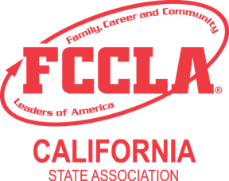
California FCCLA
STAR Events Event Online Orientation Documentation

Thank you for completing the STAR Events Participant Online Orientation for this year’s upcoming competition! To receive the point for completion on the Room Consultant rubric, print this page and have your advisor verify by signing and dating below. Bring this signed form with you when you compete and submit it to your event Room Consultant at the time of your event presentation.

Chapter Name: ______________________________________________

Name of Event: ______________________________________________

Category (Level 1, 2, 3): _______________ Region: _______________

Participant Name: ____________________________________________

Participant Signature: ________________________________________

I verify that the participant listed above has viewed the STAR Events Participant Online Orientation video and related materials available on the CA FCCLA website.

Chapter Advisor Signature: ____________________________________

Date Orientation Completed: ___________________________________

Submit this form to the Room Consultant at the time of your event presentation.

