Region 4
August 2016
Officer Introductions

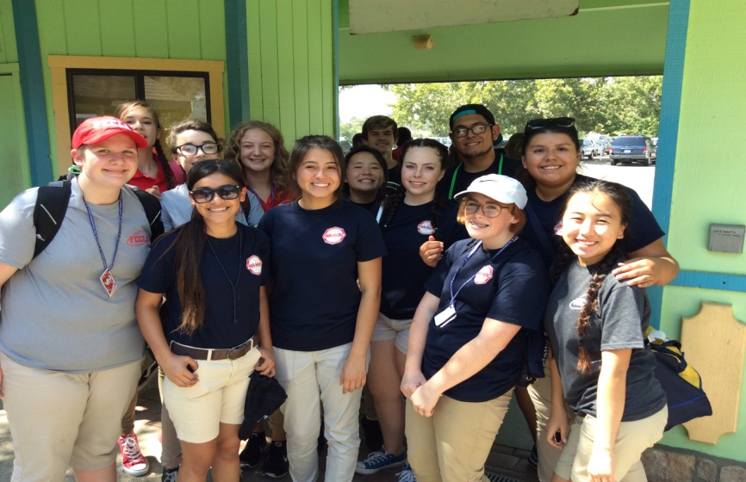

Samantha Jamison – Secretary  Samantha is a junior at San Juan High School. She enjoys school and hanging out with friends. When she’s alone, she likes to take naps and watch Netflix. She has a cat named CiCi. She also likes going to Starbucks then going across the street to get her nails done. What she likes about FCCLA is that she gets to compete and win trophies and the fun activities that FCCLA provide. | Lizbeth Brambila – Historian  Lizbeth Brambila is a senior at San Juan High School. She is easy to get along with and outgoing. Lizbeth enjoys playing soccer, and is also a core team member of the Latino Dreams Multicultural Club. She likes being part of FCCLA because it has helped her grow her personal skills. Lizbeth wants to go to college after high school and graduate in the psychology field. | Lucy Andrew – Reporter  Lucy Andrew is a sophomore at Rocklin High School. She has enjoyed being involved in FCCLA. Lucy likes to listen to music and craft in her spare time. She would like to learn construction skills in the future and wants to be a T.V. set/movie set designer. Lucy enjoys participating in FCCLA leadership positions and hopes to serve as state and national office later on.
Region 4
Upcoming Events:
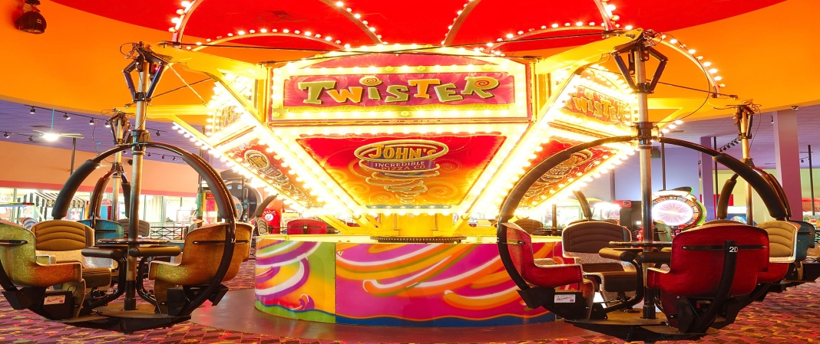
- John’s Incredible Pizza: Come hang out with and get to know the Region 4 members and officers! September 10th, 11:00-2:00 @ 384 N Sunrise Ave, Roseville, CA 95661. RSVP by 9/6/2016 to: dgoldman@fcusd.org

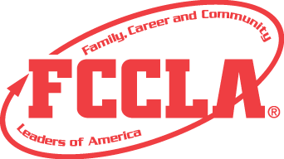
- T-Shirt Design Contest: We’re hosting a contest to see who can come up with the best shirt design for Region 4. Send entries by 9/16/2016 to: dgoldman@fcusd.org

2016 Fall Region Meeting: Cordova High School, September 24th. Registration & Breakfast 8:00-9:00, meeting ends around 3:00.

