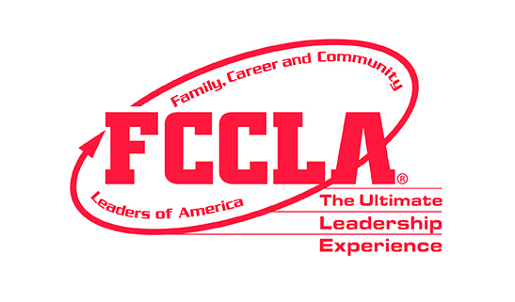

FCCLA Chapter ID Request Form

Step 1: Please type information to this form and submit to Melissa Webb, FCCLA State Advisor,
at mwebb@cde.ca.gov.

School Name
Chapter Name: Ex. Lakewood HS FCCLA
School Type: Middle or High School
School Address
School City, State, Zip
School Phone
Family & Consumer Sciences Program Types:  Comprehensive Program (concentrator courses) Ex. Foods and Nutrition  Occupational Program (capstone courses) Ex. Advanced Culinary  or Both (FCS program includes both concentrator and capstone courses) | List FCS Program Type and Course Titles:
School Fax
County
Region 2, 4, 5, 6, 7, 8, 9, or 10
Grades served
District
Principal Name
Principal Email
Advisor Name
Years Teaching FCS Courses
Years Serving as Chapter Advisor
Advisor Address
City
State
Zip
Phone
Cell Phone
Home Email
School Email
Affiliation Type:
□ Middle School Level: Total $450.00
□ Regular: $18.00 per member/advisor
□ Up to 25 Members: $790 plus pkg. benefits
□ Unlimited Package: all FCS students in your courses: $1,550 plus pkg. benefits

Step 2: You will also need to complete and submit the FCCLA Chapter Participation Form which both you and your administrator will need to sign.

Step 3: Melissa Webb will email you the Chapter ID number and login credentials to access the FCCLA National Advisor Affiliation Portal at www.fcclainc.org. (Revised 7-21-2023)

