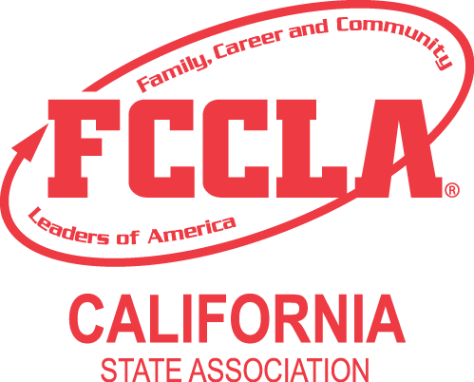
Sponsored by Family and Consumer Sciences Education

CALIFORNIA DEPARTMENT OF EDUCATION
1430 N STREET, SUITE 4202
SACRAMENTO, CA 95814
www.ca-fccla.org

2024 State Leadership Conference
“The Ultimate Journey”

California FCCLA and its sponsor, Family and Consumer Sciences Education, California Department of Education, invites members, advisors, and their guests to participate in the 77th Annual State Leadership Conference (SLC) in Riverside, CA. “The Ultimate Journey” is the theme for the four-day conference.

The 2023–24 FCCLA State Officers have planned a conference that will involve and inspire members and advisors to increase pride and commitment in FCCLA. Conference sessions and activities will be held at the Riverside Convention Center and the Riverside Marriott. Lodging will be available at the Riverside Marriott (host hotel), along with the Hyatt Place, Mission Inn and Hampton Inn.

We recommend you visit the California FCCLA website at www.ca-fccla.org. There you will find information about the upcoming SLC, nomination and election of state officers, the Students Taking Action with Recognition Events (STAR) state finals, conference registration and hotel reservations, as well as other materials to assist you in planning for your participation in the conference.

PLEASE NOTE – There are significant changes to this year's STAR State Finals Events. CAREFULLY review these materials so that you are up to date on changes!

This release provides general information about the upcoming SLC for California FCCLA. For your convenience and ease, this page delineates basic information about the conference and provides an index at the bottom of this page to guide you through the balance of the information currently available in this release.

CONFERENCE DATES: April 27–30, 2024

CONFERENCE LOCATION: Riverside Convention Center, 3443 Orange Street, Riverside, California 92501

CONFERENCE LODGING: Chapters must lodge at the Riverside Marriott, 3400 Market Street, Riverside, CA 92501, 951-784-8000 with small room blocks at Mission Inn, Hyatt Place and Hampton Inn - see hotel information sheet for more details.

CONFERENCE OBJECTIVES: The SLC will focus on uniting and assisting members to:
- Develop leadership and decision-making skills
- Expand pride for FCCLA and Family and Consumer Sciences Education
- Become aware of Family and Consumer Sciences related careers

REGISTRATION DEADLINE: The postmark deadline for advance conference registration is April 1, 2024.
State Conference Registration will open March 4, 2024. Various conference information and application forms will be available on the website shortly. A general announcement will be sent to all chapters via email when registration forms become available online.

WHO MAY ATTEND? FCCLA members and advisors, STAR competitors, Pre-service Education Students preparing for a career as a Family and Consumer Sciences educator, school administrators, parents, and guests are all welcome and encouraged to attend.

HOW MANY MAY ATTEND? Chapters affiliated with California FCCLA for the current school year may bring an unlimited number of members, advisors, and guests. (An affiliated chapter is a school that has submitted leadership packet and affiliation materials and has a membership roster on file at the state FCCLA Financial Services Office.) Non-affiliated chapters are limited to participation for observational purposes.

SUPERVISION REQUIREMENT: All students attending the SLC must be accompanied by an advisor/teacher from their school. Students may only be chaperoned by an advisor from another school when a letter authorizing the arrangements is submitted with registration forms. The letter must be signed by principals from the schools of both the student and the supervising teacher.

COVID INFORMATION: Included in this packet will be a detailed COVID letter providing attendees with CA FCCLA protocols while onsite at the SLC.

TRANSPORTATION TO AND FROM RIVERSIDE: Transportation to and from the SLC is the responsibility of each local chapter.
- Air: Those chapters which choose to arrange airline transportation for its participants will need to fly to the Ontario Airport (Federal Airport Designation: ONT).

- Train: For those chapters wishing to travel to Riverside by rail, call Amtrak at 1-800-USA-RAIL (1-800-872-7245) or log on to http://www.amtrak.com to make reservations and purchase tickets.

- Private Automobile/Parking: Specific maps and directions will be provided in the next set of meeting information. Parking is available at the Riverside Marriott Hotel for $19.00 a day and at the Riverside Convention Center. Buses must park at the Riverside Convention Center.

Your cooperation and assistance with all conference activities will be appreciated and will help to make the 2024 SLC a successful and memorable leadership activity. If you need additional information, please contact the appropriate personnel as shown below:

Question/Information Needed Contact Person Email Address Phone
Conference Behavior/
Responsibilities Melissa Webb mwebb@cde.ca.gov 916-319-0773
STAR Events/Rules/
Participation Pat Peck patpeck47@gmail.com 916-955-6400
State Officer Candidates Maria Pimentel mariapimentel2727@gmail.com
VIPs/Sponsors/
Career Fair Beth Bettencourt bbettencourt@ca-fccla.org 916-932-2200
Fashion Show Maria Pimentel mariapimentel2727@gmail.com
Convention Logistics &
Coordination Beth Bettencourt bbettencourt@ca-fccla.org 916-932-2200
Hotel Reservation Ask for the FCCLA Room BLOCK 951-784-8000
State Conference
Registration Tracy Brown tracyb@4arc.com 916-932-2200

GUIDE TO REMAINING MATERIALS IN THIS MAILING:
We look forward to seeing you in Riverside! The following forms are also available at
www.ca-fccla.org.

- FCCLA SLC Mailer Memo Cover
- Registration Information
- Hotel Information
- Hotel Reservation Form
- Pre-State Conference Checklist for Advisors
- Advisor Duties and Responsibilities
- Participant's Conduct and Responsibility Form
- 2022-24 FCCLA Guidelines for Conduct, Dress, and Travel
- Sample Letter to Parents
- STAR Information
- COVID Information
- Fashion Show Flyer (pending)
- Fashion Show Application and Consent Form (pending)
- 2024 FCCLA Schedule-At-A-Glance
- 2024 FCCLA DETAILED Schedule-At-A-Glance (pending)
- 2024 Save the Date Flyer

