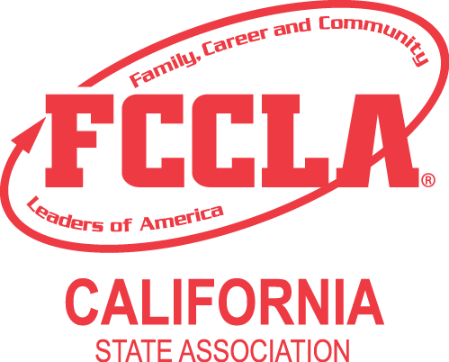

Advisor Duties and Responsibilities – FCCLA State Leadership Conference

- FCCLA is an integral part of Family and Consumer Sciences instructional programs. Attendance at this conference may be identified as an authorized school field trip. Expenses for this conference are a valid expenditure of the Carl D. Perkins Vocational and Applied Technology Education Act of 1998 (PL 105-332).

- Advance planning is necessary in order to make the annual FCCLA State Leadership Conference (SLC) a positive learning experience for all delegates and advisors. The following suggestions are given to ensure that everyone attending is prepared in advance for this special event:

PRIOR TO ANNUAL FCCLA STATE LEADERSHIP CONFERENCE

- Inform all of your members about the information contained in this conference packet. Let members assist in putting together the various forms, reservations, etc. Establish special committees to accomplish these tasks.

- Prepare and send permission slips for members to parents and guardians. Include a cover letter, the “Delegate’s Conduct and Responsibility Sheet,” and the “Guidelines for Conduct and Dress.” A sample letter is included in these materials which you can use as a guide in preparing your cover letter.

- Inform each and every member participating of the included “Guidelines for Conduct and Dress” developed by the State Executive Council. This may be the first trip out of the community for some of your members, the first hotel they have been in, etc. If they know what to expect, they will enjoy the conference experience more. Prior to attending the SLC, be sure to stress the importance of official uniform and appropriate dress.

- All Chapter Advisors must also wear FCCLA official dress for all General Sessions.

- Encourage qualified members to run for state office. FCCLA is a leadership and career development program. Every affiliated chapter should try to have an officer nominee.

- Make sure each person participating knows what part they have in the SLC.

Voting Delegates - (Affiliated Chapters Only)
A voting delegate represents the chapter during elections and the business meeting. Select these delegates in advance. Make sure they attend all sessions designated for official voting delegates. Only these representatives will be allowed to vote in the elections, on amendments to the Bylaws, and any other business to come before the Association. Other special events are in store for Official Voting Delegates this year. NOTE: This year Students competing CAN serve as Official Voting Delegates.

Other Members/Students -
Inform them of what to expect at the SLC and what their function is in representing the chapter. Each person should be responsible for reporting the SLC happenings to their chapter. Many leadership development opportunities abound at the SLC. Do not limit SLC participation to STAR participants and voting delegates only. All members should be encouraged to attend the SLC and take advantage of growth opportunities.

Candidates -
Should be thoroughly familiar with FCCLA facts and materials and must attend an orientation meeting prior to the officer candidate interview where they will be screened by their peers. Each candidate must come prepared with a 2-minute campaign speech on the designated speech topic, official uniform, and one campaign poster. Please review the State Officer Candidate Election Guide prior to arriving in Riverside. Additional information will be sent directly to candidates after their applications are received.

Advisors of Candidates -
Advisors should review information contained in the letter to the candidate with the candidate. In addition, advisors should be certain the State Officer Candidate has the California official uniform and is knowledgeable of the “Guidelines for Conduct and Dress.”

- Review FCCLA opening and closing ceremonies with your students so they can actively participate in sessions where these are used. This can be found in your affiliation packet or www.ca-fccla.org under “Resources.”

DURING THE ANNUAL FCCLA STATE LEADERSHIP CONFERENCE

- Since you and your members have been given release time from school to attend this conference, it is expected that your entire delegation will attend and participate in all sessions and activities. Being in hotel rooms, downtown shopping, engaged in recreational activities, or lengthy meals are not acceptable behaviors at any time when any type of SLC activity is taking place. It is up to you, the local advisor, to make certain that students are productively spending their time at official SLC activities, not in other activities such as those listed above.

- Know where YOUR members are at all times. Let them know you care and are interested. Be clear with members that they are expected to be engaged in official SLC activities at all times while any sessions, workshops, activities, etc., are in progress! Meet with your entire chapter delegation each evening before bedtime. Ask each member to review where they were throughout the day, what activities they attended, and what was learned. Help every member develop their individual plan for the next day and make sure each student knows you expect them to follow that plan and attend those activities unless they check in with you first before making alterations. Tell them to remember that they will be expected to report back on all of the events tomorrow evening when you meet again!

- Only you, as an advisor, can pick up packets for your members during SLC registration.

- Some advisors will be asked to assist with portions of the conference. Detailed information will be sent to you if you have been asked to assist.

- The Annual FCCLA SLC is held at a hotel where guests who are not with our conference will also be present, and the actions of all FCCLA members will be under close observation. Please spend some extra time preparing your members with respect to appropriate dress and conduct so they will create the best possible image for the entire FCCLA organization. Well-behaved and articulate members are the best public relations our organization can have.

- YOU are responsible for YOUR students at all times during the SLC. Responsibility and liability are incumbent upon YOUR school district, NOT California FCCLA, the Family and Consumer Sciences State Staff, or the California Department of Education.

