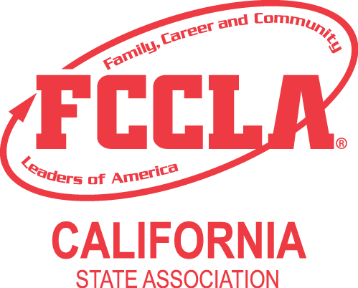

School Name: ______________________________

PARTICIPANT’S CONDUCT AND RESPONSIBILITY FORM

As a participant attending the California FCCLA State Leadership Conference (SLC), you will have an opportunity to learn more about FCCLA, gain valuable leadership and citizenship skills, learn more about careers, represent your chapter, and meet the State Officers and other members from throughout California. With this opportunity, you will also have responsibilities to fulfill.

Listed below are responsibilities for chapter representatives. This form must be completed and submitted to your advisor prior to departure for the conference.

As a member/representative, I will:

A. At the FCCLA SLC:

- Attend and participate in ALL sessions and activities

- Gain ideas and information to share with my chapter and region

- Abide by the “Guidelines for Conduct and Dress” established by the State Executive Council

- Abide by the curfew decided upon by the State Executive Council

- Carry out directions and requests of the advisors at the conference

- Abide by all CA FCCLA COVID protocols as determined by State and local County regulations.

- While onsite, follow all COVID protocols set forth by the FCCLA Board of Directors and Conference Staff.

B. Following FCCLA SLC:

- Share information and ideas I learned at the SLC with my chapter members and advisor.

I have carefully read the above information. I understand that any infraction of the guidelines for conduct will be sufficient cause for termination of my participation in the SLC and for me to be sent home at my own expense.

Print Member’s Name: ___________________________________

Member's Signature Date
I have carefully read the information regarding this SLC and understand the conditions for participation. Further, I understand that in the event my child violates the established guidelines for conduct and dress after being informed and signing the contract for conduct, my child will be sent home early at our expense. I will not hold the advisor or school district responsible for my child’s inappropriate behavior. I give my permission for my child to attend this SLC.

Parent/Guardian's Signature Date __________

California FCCLA sometimes authorizes the photographing and/or videotaping of group sessions during the FCCLA SLC. I understand that students, including my child, may be photographed and/or filmed while attending the SLC. The photos/video tape will be used as part of a program or promotional effort. Individuals will not be identified by name or school. I give permission for my child to be included in any photographs and/or video shots authorized by California FCCLA while attending the SLC.

Parent/Guardian's Signature Date __________

ALL STUDENTS AND THEIR PARENTS/GUARDIANS MUST READ AND SIGN THIS RESPONSIBILITY FORM PRIOR TO THE STUDENT’S DEPARTURE FOR THE SLC.
CHAPTER ADVISORS MUST TURN IN THESE SIGNED FORMS
AT REGISTRATION.

