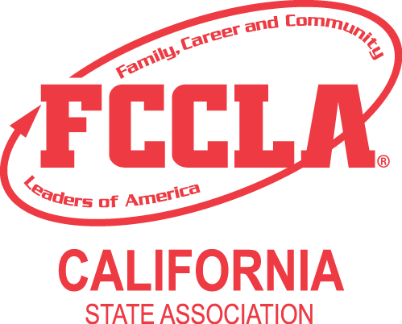
SCHOOL LETTERHEAD
SAMPLE
(For Use following Spring Qualifying Competition)

February _____, 2024

Dear Parents:

An exciting and well-deserved part of your son/daughter's involvement with California FCCLA leadership and career development activities includes attending the 2024 State Leadership Conference (SLC) in Riverside, California, from April 27–30, 2024. This annual conference is attended by approximately 700 students, advisors, and guests from throughout California. A variety of leadership activities have been planned, involving students during general sessions, workshops, industry tours, and region meetings. In addition, many of the attendees will vie for $650,000 in cash, scholarships, and awards during leadership and career development activities referred to as the Students Taking Acting with Recognition (STAR) Events.

Attendance at the FCCLA SLC is a privilege earned by the members. Appropriate conduct and dress are expected. Official FCCLA dress uniform and casual dress items are available for purchase online at: ca-fccla.org or https://fccla.mybrightsites.com/. Enclosed you will find a copy of the guidelines that will be enforced at the FCCLA SLC, as well as the “Participant's Conduct and Responsibility Form” which must be signed by both the member and parent/guardian. Please read both documents carefully, sign, and return to me by (specify date). I will be providing supervision along with other chapter advisors.

(In the event that your son/daughter does not adhere to the enclosed guidelines, you may expect a telephone call requesting that he/she be sent home early. All travel costs and any damage costs will be the responsibility of the family or guardian of the member.)

Thank you for your support.

Sincerely,

(Name of Teacher/Advisor), FCCLA Chapter Advisor
(telephone and email)

Enclosures

