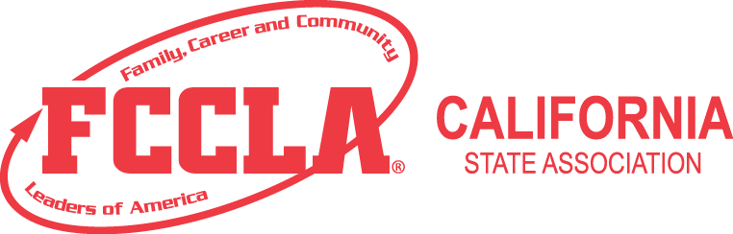
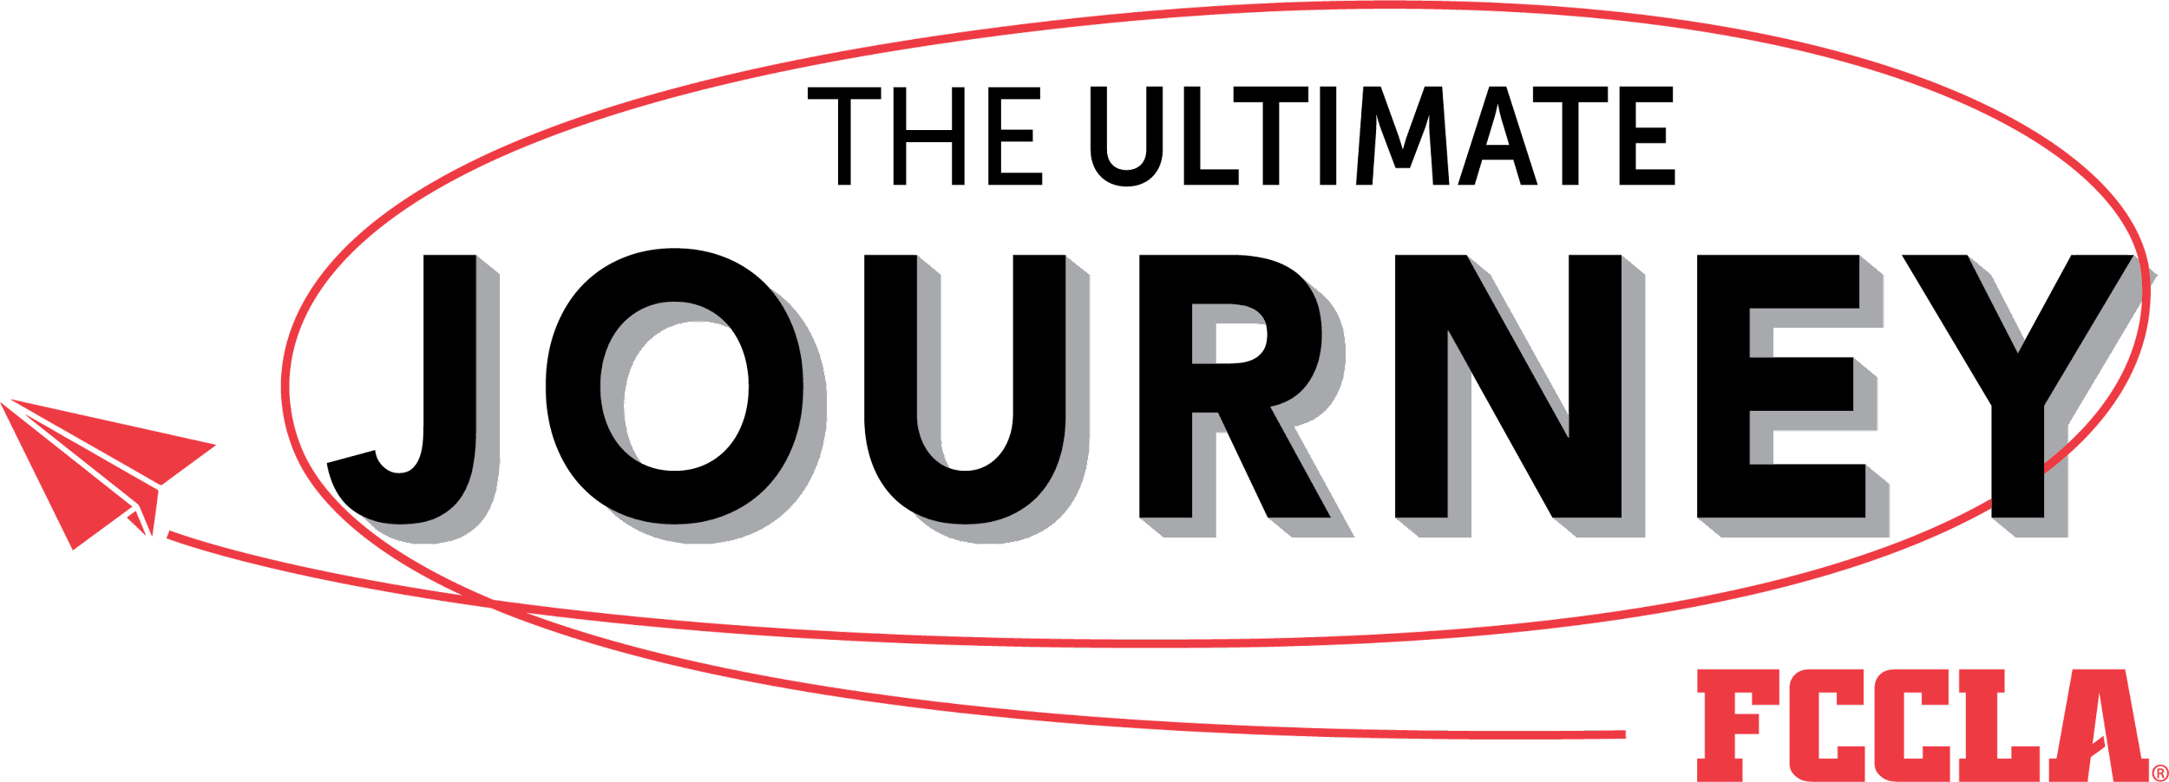

Region 10 Spring Leadership Meeting and Qualifying STAR Events
Welcome Region 10 FCCLA Chapters and Guests
STAR Competition
Official Dress and/or CHEF Attire (for Culinary Arts, Culinary Display, and Salad Preparation Events.)
--------------------------
Region Officer Candidate Applications Due Online no later than 1 Week Before Spring Meeting!

When: February 17, 2024

Where: La Quinta High School
79255 Blackhawk Way
La Quinta, CA 92253

Meeting Times: Registration/Continental Breakfast: 7:45 a.m.
Meeting Begins: 8:30 a.m.
Meeting Ends: 5:00 p.m.
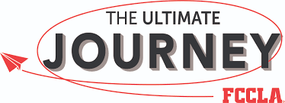
Theme:

Who’s Invited: Region 10 FCCLA Chapters and Guests
- All members
- Any student who is or has been enrolled in Family & Consumer Science classes
- FCCLA Advisers, prospective advisors and their students
- Interested parents, administrators, counselors and guests

Registration: $15.00 per person (includes breakfast, snacks, lunch and materials)

Lunch: Included with registration.

What to wear: Official Dress Uniform White Dress Shirt, Black Skirt or Pants, Black Shoes, FCCLA Blazer (optional). Culinary competitors may wear Official Chef Attire.
What to bring: Cash for the raffle and 2 - $5+ gift cards or gifts per chapter for the raffle

Program: STAR Events and community service opportunity for non-competitors.

Attendance Registration Form
return, text, or e-mail by February 2, 2024

School:________________________________________________________________

Adviser’s Name:__________________________________________________________

Registration Fee: $15.00 X__________ = $____________

PAYMENT: Cash or checks made payable to California FCCLA
Can be mailed to Financial Services directly (please include chapter name on payment)
CA FCCLA
P.O. Box 6
Galt, CA 95632

or bring cash or check to the Region meeting.

Lunch is included with registration. Please indicate how many lunches your chapter will need:
Lunches needed: __________
NOTE: Do you have any vegetarian, vegan or other special dietary needs? If so, please specify the need and how many meals.

____________________________________________________________________________________________________________________________________________________________________________________

NOTE:
For special needs or accommodations, please contact Melissa Webb, FCCLA State Advisor at least 3 weeks prior to the meeting at
(916) 319-0773
Email: mwebb@cde.ca.gov

Contact: Myeasha Pruitt
Ysmael Villegas Middle School
3754 Harvill Lane
Riverside, CA 92503
myeasha.pruitt@alvordschools.org
951.261.3890

